Program 03 :

print("ARRAY FUNCTIONS")

print("")

MyString=["Tanmay","Patil","AC Patil","SE"]

print(MyString)

MyString.append("Kharghar")

print(MyString)

MyString.remove("Kharghar")

print(MyString)

MyString.pop(3)

print(MyString)

MyString.count(3)

MyString.sort()

print(MyString)

MyString.sort(reverse=True)

print(MyString)

MyString.reverse()

print(MyString)

MyString.insert(1,"Vishwajit")

print(MyString)

ColorString2=["Red","Blue","Green","Yellow"]

MyString.extend(ColorString2)

print(MyString)

print("")

print("RANGE FUNCTIONS")

print("")

for naturalNumber in range(0,15,3):

print(naturalNumber)

print("")

print("STRING FUNCTIONS")

print("")

print(MyString[4].casefold())

print(MyString[3].find("AC"))

print("Number of 'k' in string is",MyString[3].count("k"))

print(MyString[1].split())

print(MyString)

newString="SECOND YEAR"

print("New String is",newString)

print("Is new String Lower Case?",newString.islower())

print("Is new String Upper Case?",newString.isupper())

OUTPUT :

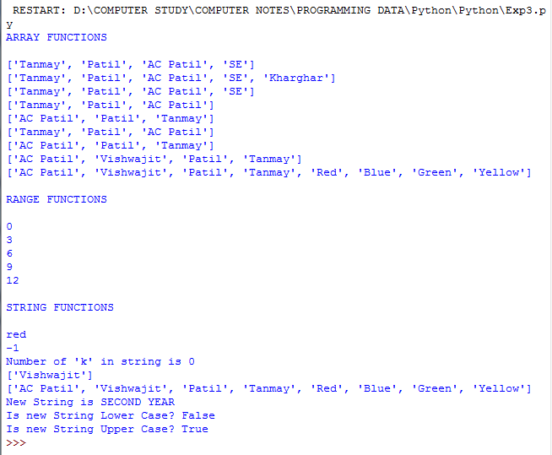

Program 04 :

#Write a python program to implement List, Tuple, Dictionarieshlist=[9,'xyz',3,6,'pqr',9.5]#creat list

hlist=[9,'xyz',3,6,'pqr',9.5]#creat list

print(hlist)

hlist1=['abc',7] #print list

print(hlist1)

hlist1[1]='hit'

print(hlist1)

print(hlist[2])

print(hlist[-1])

print(hlist+hlist1) #list concatenation

print(hlist[1:5])

print(hlist1\*3) #list repetition

hlist2=[1,2,['ab','dks'],[2.4,7.3],'hi'] #nested list

print(hlist2)

print(len(hlist))

hlist1.append('ACPCE') #List append

print(hlist1)

sublist1=['coa','aoa','graphics'] # List of subjects

sublist2=['maths4','os','python'] #another List of subjects

print(sublist1)

sublist1.extend(sublist2)

print(sublist1) #extended list

sublist1.insert(2,'java')

print("list after inserting",sublist1)

sublist2.remove('maths4')

print("list after removing",sublist2)

l=[1,1,1,2,2,2,2,2,3,3]

print(l)

print("in above list 2 occurs = ",l.count(2)) #count occurences of element

print("first elemnet of above list is",l[0])

print("list consisiting of only 1 is",l[0:3]) #slice operation

print("list consisiting of only 2 is",l[3:7])

list1=[1,2,3,4]

print(list1)

del list1[1]

print("after deletion of 2nd element ",list1)

list1[2]=['p','q','r']

print("after concatanetaion",list1) #concatenation using slice operation

del list1 #deletion of list

l1=[3,2,6,1]

print(l1)

l1.sort() # sorting of list using sort operation

print("after sorting list is ",l1)

ht=() #empty tuple

print(ht)

ht=(1,2,3) #tuple of integers

print(ht)

ht=('ac',4,5,'pqr') #tuple of mixed values

print(ht)

ht=('ac',(2,3,4),5.6) #nested tuple

print(ht)

ht=8,4,'xyx' #tuple without parenthesis

print(ht)

a,b,c=ht #tuple unpacking

print(a)

print(b)

print(c)

print(" 2nd element", ht[1]) #accesssing element using indexing

tuph=('a','b','c','d','e','f','g')

print("tuph is",tuph)

print(tuph[2])

ntup=('sam',[9,10,11],(7,9,9)) #nested tuple

print("nutup is",ntup)

print(ntup[2][1])

print(ntup[-1]) #Accessing elements using negative indexing

print(tuph[-3])

print("after slicing of tuph",tuph[1:5]) #Accessing elements using slicing

print("elemets begining to second of tuph is",tuph[:-5])

print("element 4th to end is",tuph[3:])

print("elements beg to end is ",tuph[:])

del ntup

dic1={1:"pqr",2:"hit",3:"sam"}

print("dic1 is",dic1)

print(type(dic1))

dic2={"fname":"xyz","lname":"abc"}

print("dic 2 is",dic2)

print(dic2.keys())

print("length odf dic 2 is",len(dic2))

print(dic2.values())

dic3={"fname":["sql","rr"],"lname":"qwr"}

print("dic 3 is",dic3)

print("keys of dic3 is",dic3.keys())

print(dic3.values())

print(dic3["fname"])

print(dic3["fname"].append("sun"))

print("after appending dic 3 is ",dic3)

print(dic3.values())

print(dic3)

print(dic3["fname"].insert(1,"java"))

print(dic3)

dic3.update({"no":987654321})

print(dic3)

print(dic3.update({"no":[98765,76543,1234]}))

print(dic3)

print(dic3["no"].insert(8,6666))

print(dic3)

print(dic3.update({"lname":"wdp"}))

print(dic3)

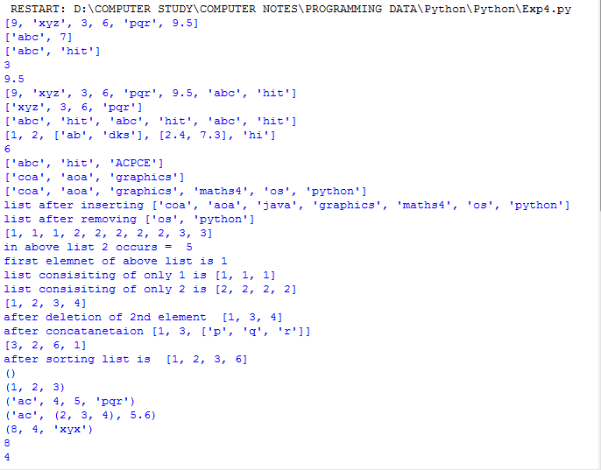

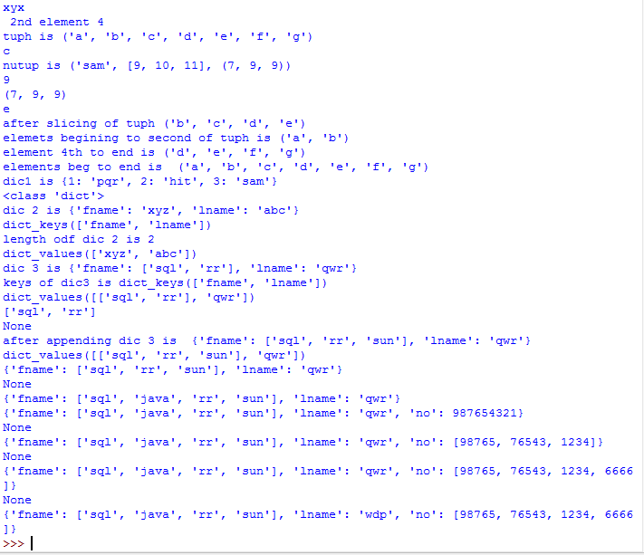

Program 05 :

def add(x,y):

return x+y

def sub(x,y):

return x-y

def multiply(x,y):

return x\*y

def division(x,y):

return x/y

def mod(x,y):

return x%y

a=int(input("Enter the first number:"))

b=int(input("Enter the second number:"))

print("Select Operation to perform:")

print("1.Addition")

print("2.Subtraction")

print("3.Multiplication")

print("4.Division")

print("5.Modulus")

n=int(input())

if(n==1):

print(a,"+",b,"=",add(a,b))

elif(n==2):

print(a,"-",b,"=",sub(a,b))

elif(n==3):

print(a,"\*",b,"=",multiply(a,b))

elif(n==4):

print(a,"/",b,"=",division(a,b))

elif(n==5):

print(a,"%",b,"=",mod(a,b))

else:

print("Invalid choice...!!!")

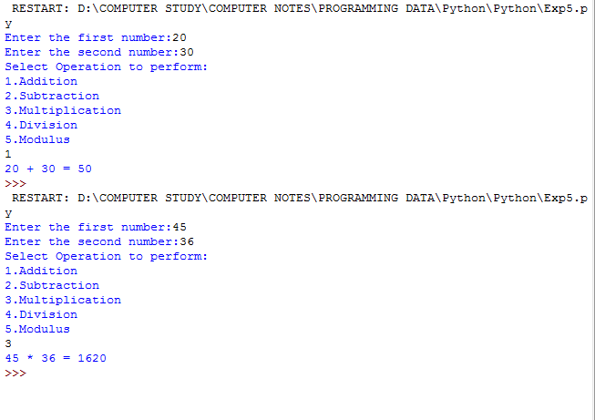

Program 06 :

#Program to convert a list of values into a set

s=set([1,23,524,"a","Shubham",34.7])

print(s)

list01=[1,2,3,4,5,4,3,2,1,6,7,9,9] #List creation

print(set(list01)) #Coversion of List into Set.

mytup=('a','b',123,3.645) #Tuple creation

print(set(mytup)) #Conversion of Tuple into Set.

a="TANMAY PATIL" #String

print(set(a)) #Conversion of String into Set.

print(set("My name is TANMAY VISHWAJIT PATIL".split()))

a={1,2,3,4,5,6,7,8,9}

b={0,2,4,6,8}

print("Union operation:",a|b,"\nIntersection opration:",a&b,"\nSet difference:",a-b,"\nSymmetric difference:",a^b,) #Menu driven of sets

a=set(input("Enter set 1:"))

b=set(input("Enter set 2:"))

print(set(a))

print(set(b))

ch='y'

while(ch=='y'):

print("Menu\n1.union\n2.Intersection\n3.Difference\n4.Symmetric Difference\n5.Exit !")

i=int(input("Your choice:"))

if(i==1):

print("Union:",a|b)

elif(i==2):

print("Intersection:",a&b)

elif(i==3):

print("Difference:",a-b)

elif(i==4):

print("Symmetric difference:",a^b)

elif(i<5):

print("Invalid choice")

else:

break

ch=input(" Do you want to continue(y/n):")

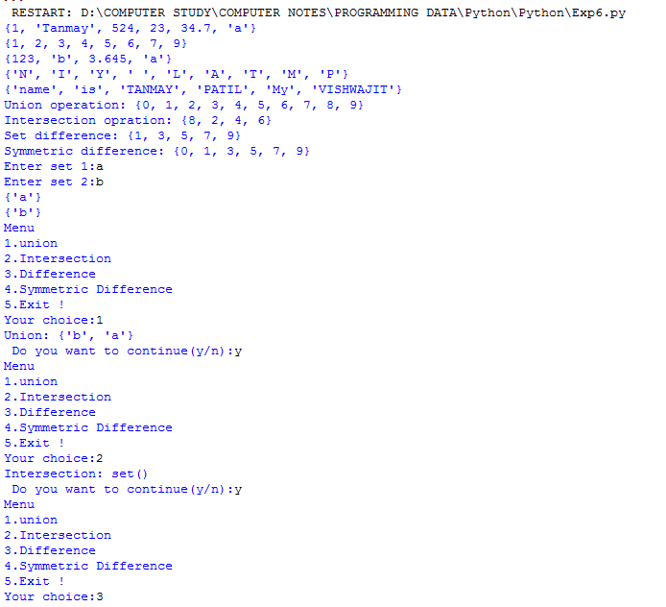

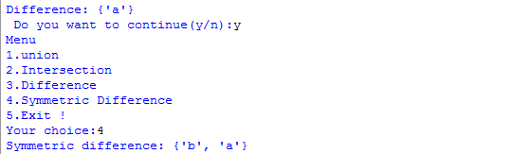

Program 07 :

#Write python program to understand different types of Exceptions

i=1

while i<=5:

n=int(input("Please enter numbers between 1 to 5 to see diffrent Exceptions : "))

if n==1:

try:

a=int(input("Please enter number a : "))

b=int(input("Please enter number b (put b=0): "))

c=a/b

except ZeroDivisionError:

print("Oops! Number Divisible by Zero Exception Occurs.")

else:

print("Division is",c)

elif n==2:

try:

a=int(input("Please enter number a : "))

b=int(input("Please enter number b (put b='a'): "))

c=a/b

except ValueError:

print("Oops! Value Error Exception Occurs.Please enter a valid number.")

else:

print ("Division is",c)

elif n==3:

try:

a=int(input("Please enter number a : "))

b=int(input("Please enter number b : "))

c=k/b

except NameError:

print("Oops! Name Error Exception Occurs due to c=k/b (k is not defined ).Please enter valid variable number.")

elif n==4:

try:

r='2'+2

except TypeError:

print("Oops! Type Error Exception Occurs (due to '2'+2).Please Provide Valid data type. ")

elif n==5:

try:

n=int(input("Please enter Numbers between 2 to 3: (Check for other nos) "))

assert n>=2 and n<=3

print("The Number Entered is",n)

except AssertionError:

print("Oops! Assertion Error Occurs..Please enter number between 2 to 5.")

else:

print("Exiting The Program")

exit()

i+=1

